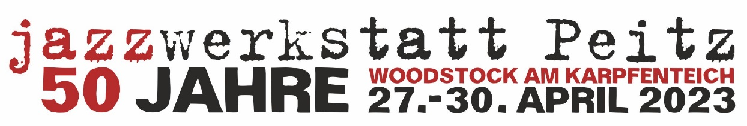
------------------------------------------------------------------------------------------
Do., 27. April 2023, 20.00 Uhr / Institut Français Berlin
MARC SCHMOLLING SOLO
MARC SCHMOLLING piano
WOLFGANG SCHMIDTKE ORCHESTRA - TO KURT WEILL
JOHN-DENNIS RENKEN / MATTHIAS SCHWENGLER / NIKOLAUS NEUSER / RYAN CARNIAUX trumpets // PETER CAZZANELLI bass trombone / GERHARD GSCHLÖßL / ANKE LUCKS / MATTHIAS MUCHE trombones // WOLFGANG SCHMIDTKE tenor saxophone, arrangements / HELGA PLANKENSTEINER baritone saxophone / KRISTINA BRODERSEN alto saxophone / MATTHEW HALPIN tenor saxophone // MICHEL LÖSCH piano / HARO ELLER double bass / BERND OEZSEVIM drums
Fr., 28. April 2023, 20.00 Uhr / Kammermusiksaal der Berliner Philharmonie
CRAIG TABORN SOLO
CRAIG TABORN piano
INSIDE COLOURS
JULIE SASSOON piano / MIA OHLMEIER drums / LOTHAR OHLMEIER bass clarinet & soprano saxophon
MARC RIBOT ORGAN TRIO
MARC RIBOT guitar, voice / GREG LEWIS hammond B3 organ / tbc drums
-------------------------------------------------------------------------------------
Sa., 29. April 2023, 18.00 Uhr / jazzwerkstatt Club in der Malzhausbastei Peitz
PODIUM: '50 JAHRE jazzwerkstatt PEITZ' / Moderation: ULF DRECHSEL mit
ULLI BLOBEL, GEROLD HILDEBRAND, THOMAS KRÜGER, BERT NOGLIK und ULRICH STEINMETZGER
KONZERT: UWE KROPINSKI SOLO
UWE KROPINSKI guitar
20.00 Uhr / Stüler Kirche Peitz
RYAN CARNIAUX WATER SPIRITS
SAMUEL DÜHSLER drums & percussion / MIKE ROELOFS fender rhodes piano & percussion / RYAN CARNIAUX cornet, flugelhorn, sea shells & percussion / DJAMEL LAROUSI guitar & percussion / STEFAN RADEMACHER bass / DIAN PRATIWI vocals & percussion
USCHI BRÜNING SINGS BILLIE HOLYDAY
USCHI BRÜNING vocals / JAN RODER double bass / MICHAEL GRIENER drums
22.00 Uhr / Festungssaal Peitz
CÉLINE VOCCIA TRIO w./JAN RODER & MICHAEL GRIENER
CÉLINE VOCCIA piano / JAN RODER double bass / MICHAEL GRIENER drums
So., 30. April 2023
15.00 Uhr jazzwerkstatt Club in der Malzhausbastei Peitz
UWE WARNKE präsentiert die CD Box: DDR-Jazz und ERNST-LUDWIG PETROWSKY in Peitz
KONZERT: CONNY BAUER & MATTHIAS BAUER
CONNY BAUER trombone / MATTHIAS BAUER double bass
17.00 Uhr / Eisenhütten-Museum Peitz
Ausstellung: FREE JAZZ in der DDR und jazzwerkstatt Peitz 2010 - 2017
Fotos von INGRID HOBERG & HERBERT WEISROCK
STEFFEN ROTH MOTUSNEU w./BRUNO ANGELONI & STEPHAN DELLE
STEFFEN ROTH drums /BRUNO ANGELONI saxophones / STEPHAN DELLE double bass
19.00 Uhr / Stüler Kirche Peitz
'VOR DER MAUER - HINTER DER MAUER'
GÜNTER BABY SOMMER / FRIEDHELM SCHÖNFELD / GUNDA GOTTSCHALK /
XU FENGXIA
GÜNTER BABY SOMMER drums & percussion / FRIEDHELM SCHÖNFELD saxophones & flute / GUNDA GOTTSCHALK violin / XU FENGXIA guzheng
SYLVIE COURVOISIER w./DREW GRESS & KENNY WOLLESEN
SYLVIE COURVOISIER piano / DREW GRESS double bass / KENNY WOLLESEN drums
HELGE LEIBERG: 'THE jazzwerkstatt PEITZ STORY' mit ALMUT KÜHNE / ULRICH GUMPERT / LOTHAR FIEDLER / HEINER REINHARD / LARS RUDOLPH
ALMUT KÜHNE vocals / ULRICH GUMPERT piano / LOTHAR FIEDLER guitar / HEINER REINHARD bass clarinet & tenor saxophone / LARS RUDOLPH trumpet
23.00 Uhr / Festungssaal Peitz
PETER EHWALD STAMP w./TOMASZ DABROWSKI / STEFAN SCHULTZE / ANDREAS LANG / MORITZ BAUMGÄRTNER
PETER EHWALD tenor saxophone / TOMASZ DĄBROWSKI trumpet / STEFAN SCHULTZE piano / ANDREAS LANG double bass / MORITZ BAUMGÄRTNER drums

